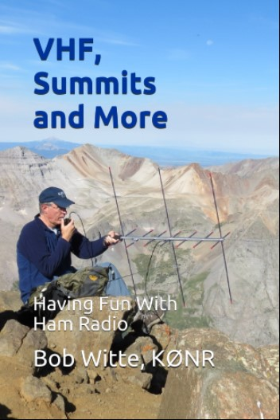
New Ham Radio Book

Title: VHF, Summits and More
Subtitle: Having Fun with Ham Radio
Author: Bob Witte, KØNR
ISBN 978-1795613194
Published Nov 1, 2019
Available in Paperback and Kindle formats
from Amazon.com and other outlets

This book is an easy-to-understand introduction to VHF/UHF ham radio, including practical tips for getting on the air and having fun messing around with radios. Learn about FM, SSB, repeaters, equipment, band plans, phonetics, portable operating, Summits On The Air (SOTA) activations and more. This book is a compilation of the best articles from the k0nr.com website plus some brand-new material.
The first section explains VHF/UHF concepts via tutorial articles such as “VHF FM Operating Guide,” “Getting Started on 2m SSB” and “How to Work a VHF Contest.” The second section includes blog posts from the k0nr.com website, such as “Choose Your 2m Frequency Wisely,” “VHF Grid Locators,” “Phonetic Alphabets” and “VHF FM: The Utility Mode.” The final section helps the reader understand mountaintop operating, especially Summits On The Air (SOTA) activations, including operating tips and trip reports.

About the Author
Bob Witte enjoys a wide variety of amateur radio activities, HF through UHF. He has a passion for VHF mountaintop operating and is active in the Summits On The Air (SOTA) program. He can often be found exploring the Colorado mountains, always with ham radio gear in hand. As an author, Bob has written for QST, CQ, CQ VHF, QRP Quarterly and his own blog at k0nr.com.

Contact
Bob Witte, KØNR
bob@k0nr.com
Website: www.k0nr.com
Phone: 719 659-3727

Media Kit available at http://www.k0nr.com/wordpress/media-kit

